

Capstone Project- Retail Analysis

By Kapil Dhiman -Data Analytics



Accio Jobs

Gurugram

Over View Of PROJECT

**Retail analysis involves examining sales data, customer behavior, and market trends to optimize inventory, pricing, and marketing strategies, enhancing overall business performance and customer satisfaction in the industry.**

**Data Collection from GitHub:**

Acquire the necessary dataset from a specified GitHub repository, including vital details on sales, customer behaviors, product metrics, and demographic insights across diverse countries, assessing their standings in distinct ranking systems.

2. Data Transformation and Enhancement:

implement data transformation procedures to ensure data quality and consistency. Additionally, contemplate enhancing the dataset with novel problem statements to enrich the analytical potential.

3. Connecting the Data with Analytical tools:

Establish links between the dataset and diverse analytical tools. Integrate the dataset with Power BI, Excel, and MySQL Workbench to enable smooth data processing and integration.

4. Problem Statement Solution in Power BI:

Usage of Power BI to explore the designated problem statements. Leverage its powerful features for effective data visualization, exploration, and analysis, deriving valuable insights.

5. Exploratory Data Analysis (EDA) :

Conduct exploratory data analysis using either Excel or SQL Workbench, depending on the analysis complexity. Extract significant patterns, relationships, and trends from the data to inform subsequent decision-making.

6. Creation of Visual and Insightful PowerPoint:

Create a detailed PowerPoint presentation outlining the project's goals, methodologies, solutions to problem statements, and key visualizations. Dedicate specific sections to each problem statement, providing relevant conclusions and insights while ensuring originality

7. Detailed Documentation:

Produce a comprehensive report meticulously documenting the entire project lifecycle. Cover aspects such as data collection, transformation, formulation of problem statements, integration of tools, Power BI solutions, insights from exploratory data analysis, and detailed information on PowerPoint visualizations.

Objective

Retail analysis involves a detailed examination of store operations to make informed decisions. It encompasses various aspects, such as understanding customer purchasing behavior, the quantity and timing of purchases. This analysis allows stores to determine optimal pricing, identify popular products, and maintain adequate stock levels.

Furthermore, retail analysis aids in understanding customer preferences and shopping habits, whether they prefer in-store or online experiences. By discerning effective selling approaches, stores can enhance customer satisfaction.

Stores also engage in benchmarking, comparing their performance with other retailers to learn and improve. They monitor market trends and economic conditions to make strategic decisions.

In summary, retail analysis is crucial for stores to optimize their strategies, improve customer satisfaction, and stay attuned to market demands, acting as a guide for making informed choices and fostering growth.

Significance

Comprehensive documentation of retail analysis is crucial for various reasons. Firstly, it provides a thorough understanding of consumer behavior, preferences, and buying patterns, essential for strategic decision-making. By documenting and analyzing retail data, businesses gain insights into product performance, pricing effectiveness, and demographic preferences, aiding in optimizing inventory management and meeting consumer demands efficiently.

Additionally, retail analysis documentation facilitates the evaluation of different sales channels' performance, enabling businesses to allocate resources effectively between online platforms and physical stores. This documentation also assists in identifying trends and seasonal variations, allowing retailers to strategically plan promotions, marketing campaigns, and product launches.

Moreover, retail analysis documentation supports the assessment of pricing strategies' effectiveness by tracking sales volumes, profit margins, and customer responses to pricing changes. This enables businesses to refine pricing strategies for maximum profitability and competitiveness in the market.

In conclusion, comprehensive documentation of retail analysis is essential for data-driven decision-making, operational efficiency, and market competitiveness.

Data Dictionary:

1. Table: customers

**Customer number** (int): Unique identifier for each customer.

**Name** (varchar): First name of the customer.

**Phone** (varchar): Contact phone number of the customer.

**Address** **customer name** (varchar): Full name of the customer.

**Last name** (varchar): Last name of the customer.

**First**

(varchar) : Customer's address.

**City state** (varchar): City and state of the customer.

**Postal code** (varchar): Postal code of the customer's location.

**Country** (varchar): Country of the customer.

**Salesrep employee number** (int): Employee number of the sales representative.

**Credit limit** (decimal): Maximum credit limit for the customer.

2. Table: Employees

**last name** (varchar): Last name of the employee.

**first name** (varchar): First name of the employee.

**Extension** (varchar): Extension number for contact.

**Email** (varchar): Email address of the employee.

**Office code** (int): Unique identifier for the office.

**Report to** (int): Employee ID to whom the employee reports.

**Job title** (varchar): Job title of the employee.

3. Table: offices

**Office code** (int): Unique identifier for each office.

**City** (varchar): City where the office is located.

**Address** (varchar): Address of the office.

**State** (varchar): State of the office location.

**Country** (varchar): Country of the office.

**Postal code** (varchar): Postal code of the office.

**Territory** (varchar): Territory covered by the office.

4. Table: order details

**Order number** (int): Unique identifier for each order.

**Product code** (int): Unique identifier for each product.

**Quantity ordered** (int): Quantity of the product ordered.

**Price each** (decimal): Price per unit of the product.

**Order line number** (int): Line number for the order.

5. Table: orders

**Order number** (int): Unique identifier for each order.

**Order date** (date): Date when the order was placed.

**Required date** (date): Date by which the order is required.

**Shipped date** (date): Date when the order was shipped.

**Status** (varchar): Current status of the order.

**Comments** (varchar): Additional comments related to the order.

6. Table: payments

**Customer number** (int): Unique identifier for each customer.

**Check number** (varchar): Unique identifier for each check payment.

**Payment date** (date): Date when the payment was made.

**Amount** (decimal): Amount of the payment.

7. Table: product lines

**Product line** (varchar): Category of the product line.

**Text description** (varchar): Description of the product line.

8. Table: products

**Product code** (int): Unique identifier for each product.

**Product name** (varchar): Name of the product.

**Product line** (varchar): Category of the product line.

**Product scale** (varchar): Scale of the product.

**Product vendor** (varchar): Vendor of the product.

**Product description** (varchar): Description of the product.

**Quantity in stock** (int): Quantity of the product in stock.

**Buy price** (decimal): Purchase price of the product.

**MSRP** (decimal): Manufacturer's Suggested Retail Price.

**ER Diagram**

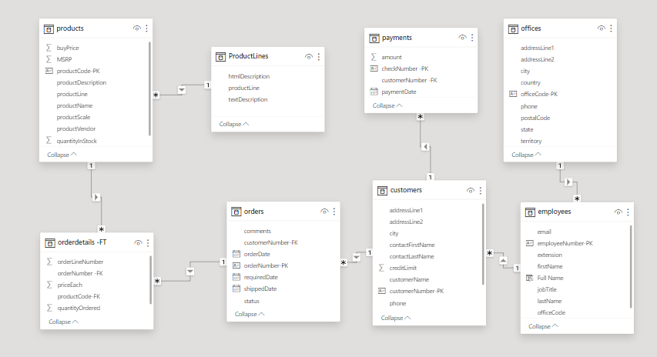

Power BI Problem Statements

**Retail Analysis**

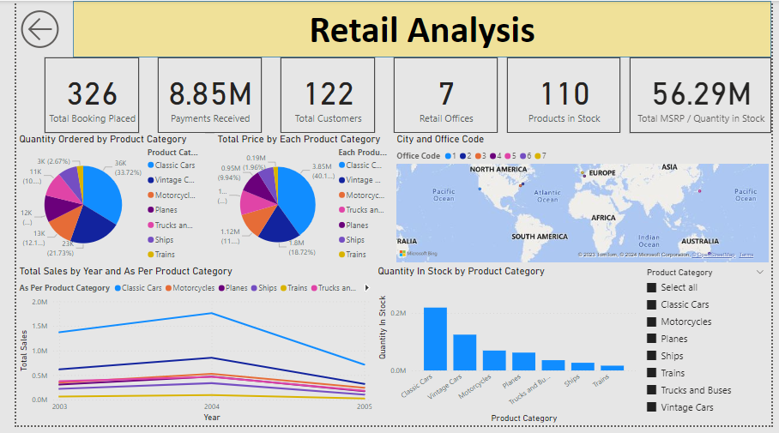

**Store Analysis**

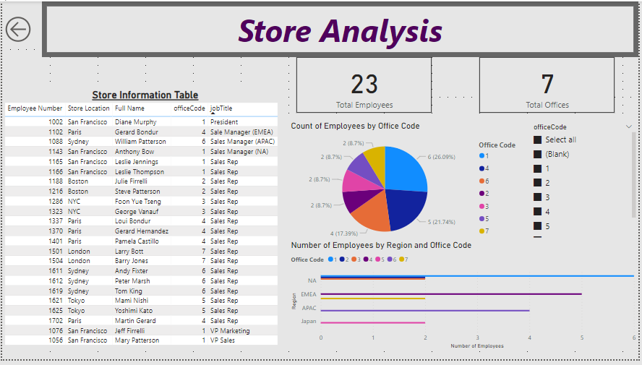

**Product Analysis**

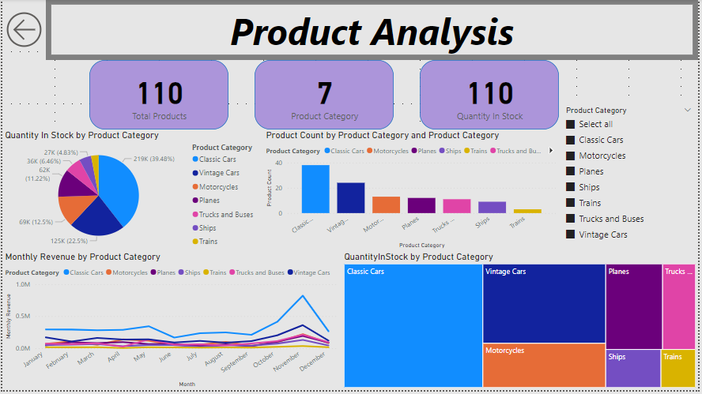

**Customer Analysis**

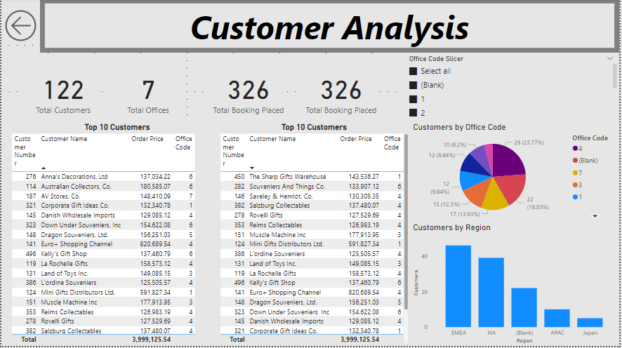

**Sales Analysis**

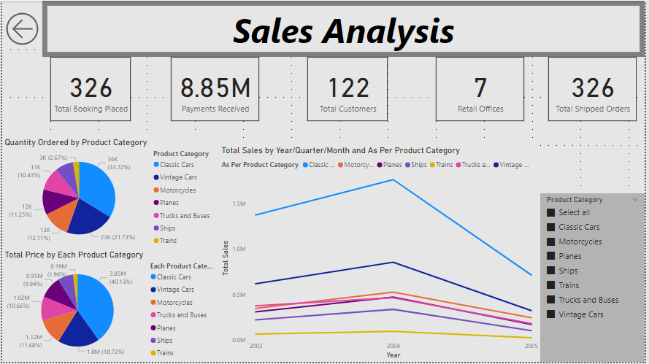

How does monthly revenue vary across different product categories? (Visual: Monthly revenue by product category)

As per the Analysis the highest Monthly revenue is in November month for all Years. where as June and August has seen decline through the years.

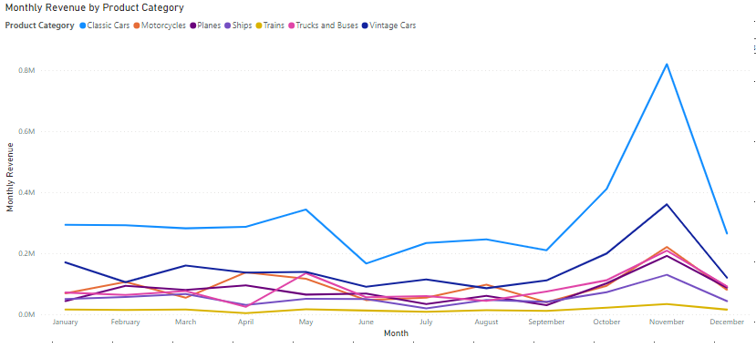

What is the trend in customer order volume over the past year? (Visual: Monthly order volume trend)

Below graph depicts the Highest Volume Trend stays in November as it has Highest order volume trend through out the years.

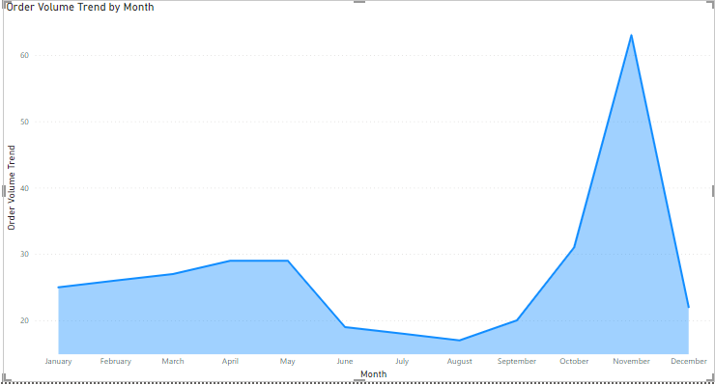

What is the distribution of product sales across different product lines? (Visual: Product sales by product line)

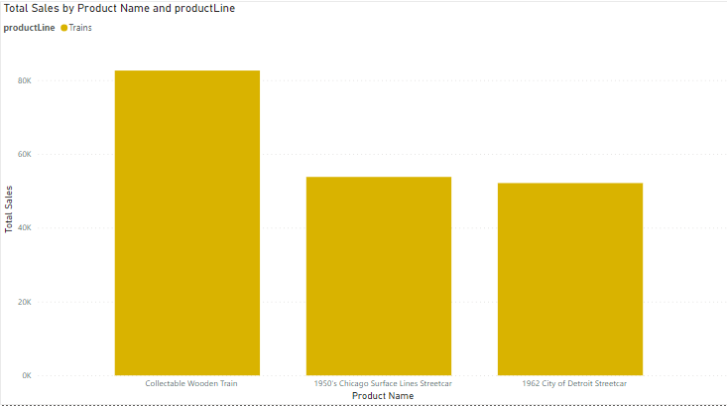

How does the profitability of different products compare based on their quantity in stock? (Visual: Profitability vs. quantity in stock)

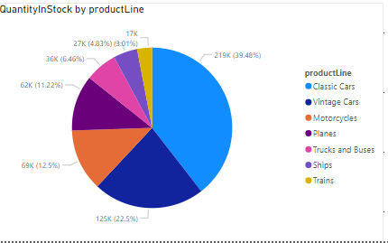

How does product pricing impact sales volume? (Visual: Product price vs. sales volume)

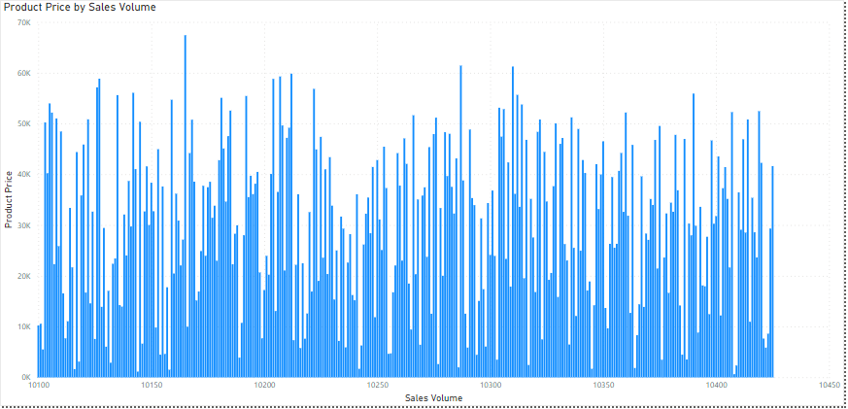

What is the distribution of customers across different demographic segments? (Visual: Customer segmentation by demographics)

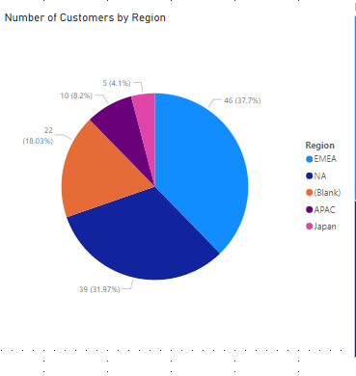

What are the top regions in terms of sales revenue? (Visual: Sales revenue by region)

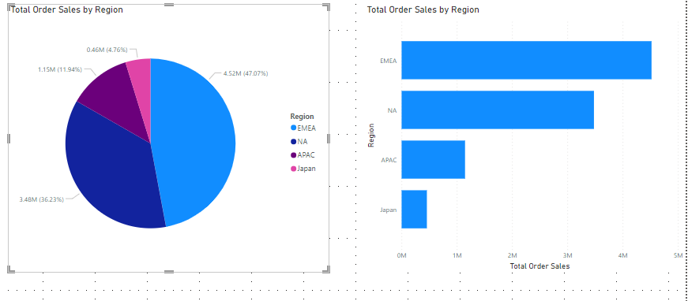

How does the performance of sales employees vary across different regions? (Visual: Employee performance by region)

